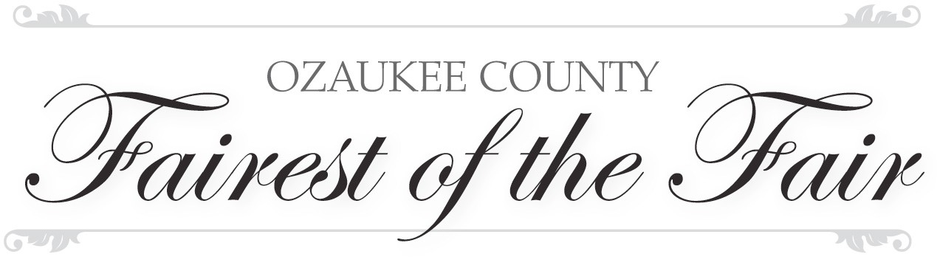

2021 Program Donations

Thank you to the following for their donations, time, and talent.

Ozaukee County Agricultural Society Ozaukee County 4-H
Ozaukee County Farm Bureau
Ozaukee County Fair Board
Fairest of the Fair Committee: Emily Rapp, Abigail Clausing, Jessie Schoessow, Patti Wilhelme, and Jody Brzezinski
Letters & Signs, LLC
Frenz Garden Center
Armbruster Jewelers
Worzella Photography Inc.
Randy and Ellie Pipkorn
LeNae Lederer Estate
Alexis Lasee, 2020 Jr. Fairest of the Fair and Family
Kallie Stewart, 2020 Fairest of the Fair

Scholarship Donors
Ozaukee County Agricultural Society
LeNae Lederer Estate
Ozaukee County Farm Bureau

Thank You

